STATISTICS FOR DATA ANALYTICS
APPLICATION ASSIGNMENT
50-Row E-Commerce / Retail Dataset
Use the provided Statistics_Data_Analytics_50_Row_Dataset.xlsx file. Apply the statistical concepts covered in the training and focus on interpretation, business reasoning and practical Data Analyst application.
Submitted by: Sowmiga Karthikeyan | Dataset: Dataset-1.xlsx (50 rows, 12 columns) | Tools: Python, pandas, NumPy, SciPy, matplotlib

1. Data Understanding
Using the Dataset sheet:
- Identify all numerical variables.
Age, Order_Value, Items_Purchased, Discount_Percent, Delivery_Days, Customer_Rating, Marketing_Spend (7).
- Identify all categorical variables.
Customer_ID, Gender, Repeat_Customer, Payment_Mode, Order_Value_Band (5).
- Identify which numerical variables are discrete and which are continuous.
Discrete: Items_Purchased, Delivery_Days, Customer_Rating, Discount_Percent, Age. Continuous: Order_Value, Marketing_Spend.
- Check for missing values.
No missing values — 0 in all 12 columns.
- Check for duplicate Customer_ID values.
No duplicates — 50 unique Customer_IDs.
- Identify the variable that represents customer spending, customer satisfaction, delivery performance and marketing investment.
Spending → Order_Value. Satisfaction → Customer_Rating. Delivery → Delivery_Days. Marketing → Marketing_Spend.
- Which variables would you consider most useful for understanding customer behaviour? Give reasons.
Order_Value (value), Repeat_Customer (loyalty), Items_Purchased (basket size), Customer_Rating + Delivery_Days (satisfaction and its driver). These measure what the customer does; Age, Gender, Payment_Mode only describe who they are.
Deliverable: Create a small data dictionary.
Column | Data Type | Variable Type | Business Meaning
Customer_ID | Text | Categorical – nominal | Unique customer ID (primary key)
Age | Integer | Numerical – discrete | Age in years (21–58)
Gender | Text | Categorical – nominal | Female 25, Male 25
Order_Value | Integer (₹) | Numerical – continuous | Order value ₹850–₹30,000; customer spending
Items_Purchased | Integer | Numerical – discrete | Items in order (1–12); basket size
Discount_Percent | Integer (%) | Numerical – discrete | Discount 0–30%
Delivery_Days | Integer | Numerical – discrete | Days to deliver (1–7); delivery performance
Customer_Rating | Integer | Numerical – ordinal | Satisfaction 1–5 (3–5 here)
Marketing_Spend | Integer (₹) | Numerical – continuous | Marketing ₹500–₹6,777; investment
Repeat_Customer | Text | Categorical – binary | Yes 16, No 34; loyalty flag
Payment_Mode | Text | Categorical – nominal | UPI 21, Debit 11, Net Banking 10, Credit 5, Cash 3
Order_Value_Band | Text | Categorical – ordinal | Low < Medium < High < Premium

2. Mean, Median & Mode
Use Order_Value.
- Calculate the mean.
Mean = ₹6,939.00
- Calculate the median.
Median = ₹5,500.00
- Find the mode, if applicable.
No mode — all 50 values are unique.
- Compare mean and median.
Mean (₹6,939) > Median (₹5,500) → right-skewed.
- Which measure would you use to describe the typical customer order value?
The median, ₹5,500.
- Explain why.
The mean is pulled up by four very large orders; 64% of customers spend below it.
Challenge:
If management asks, “How much does a typical customer spend?”, would you report the mean or median? Defend your answer.
Median ₹5,500 for "typical spend"; mean ₹6,939 only for total revenue planning.

3. Variance & Standard Deviation
Use Order_Value.
- Calculate variance.
Variance = 29,681,866.33 (ddof = 1)
- Calculate standard deviation.
Standard deviation = ₹5,448.11
- Is customer spending tightly concentrated or widely spread?
Widely spread — SD is 78.5% of the mean; range ₹850–₹30,000.
- What does the standard deviation tell you?
Orders typically vary about ₹5,448 from the ₹6,939 average.
- Why is standard deviation easier to communicate than variance?
SD is in rupees, the same unit as the data; variance is in rupees squared.
- Does a high standard deviation necessarily mean the data is bad?
No — it means customers are diverse, not that the data is wrong.
Business Question: If two stores have the same average order value but different standard deviations, what does that tell you?
Same average but different customer mix: the low-SD store is predictable, the high-SD store depends on a few large customers and is riskier.

4. Quartiles, Percentiles & IQR
Use Order_Value.
- Calculate Q1.
Q1 = ₹3,587.50
- Calculate Q2.
Q2 = ₹5,500.00
- Calculate Q3.
Q3 = ₹8,325.00
- Calculate IQR.
IQR = 8,325.00 − 3,587.50 = ₹4,737.50
- Calculate P25, P50, P75 and P90.
P25 = ₹3,587.50 · P50 = ₹5,500.00 · P75 = ₹8,325.00 · P90 = ₹12,650.00
- What does Q1 mean?
25% of customers spend ₹3,587.50 or less.
- What does Q3 mean?
75% of customers spend ₹8,325 or less.
- What percentage of observations lie below Q3?
75%.
- What does P90 mean?
90% of customers spend ₹12,650 or less; the top 10% spend more.
- What does IQR tell us about customer spending?
The middle 50% of customers spend between ₹3,587.50 and ₹8,325.
Business Challenge: The marketing team wants to target the top 10% of customers based on spending. Which percentile would you use? Explain how you would identify those customers.
P90 = ₹12,650. Filter df[df.Order_Value >= 12650] → 5 customers: C004, C044, C007, C009, C008.

5. Outlier Investigation
Use Order_Value and apply the IQR method.
- Calculate Q1, Q3 and IQR.
Q1 = ₹3,587.50, Q3 = ₹8,325.00, IQR = ₹4,737.50
- Calculate the lower boundary and upper boundary.
Lower = 3,587.50 − 1.5(4,737.50) = −₹3,518.75. Upper = 8,325.00 + 1.5(4,737.50) = ₹15,431.25
- Identify potential outliers.
Four: C004 ₹30,000, C044 ₹22,000, C007 ₹18,000, C009 ₹15,500.
- Are these observations necessarily errors?
No — all four bought 12 items, so the values are consistent. They are genuine records.
- Give possible business reasons for a very high order.
Bulk or family order, premium/big-ticket category, B2B or reseller, festival or wedding purchase, VIP customer.
- Calculate the mean before investigating the outlier.
Mean = ₹6,939.00
- Recalculate the mean after excluding the potential outlier.
Excluding ₹30,000: ₹6,468.37. Excluding all four: ₹5,683.70.
- How much did the mean change?
By ₹470.63 (6.8%) for one outlier; ₹1,255.30 (18.1%) for all four. The median barely moved.
Important Question: Should a Data Analyst automatically delete an outlier? Explain your answer.
No. Investigate first, then decide. Delete only if it is a data error; keep genuine extreme values.

6. Histogram & Boxplot
Create a histogram and a boxplot for Order_Value.
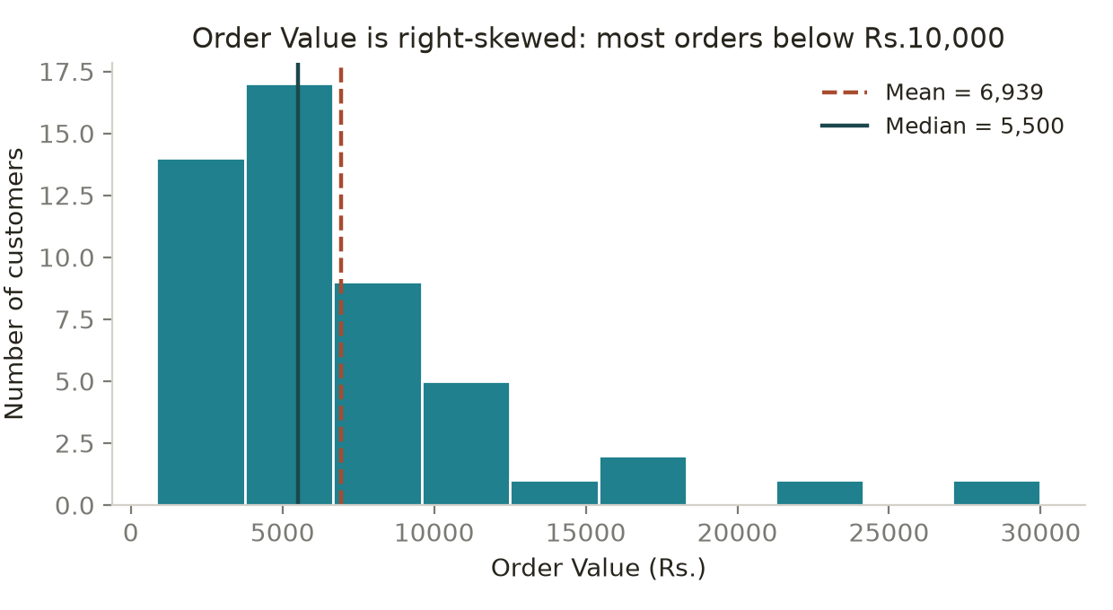
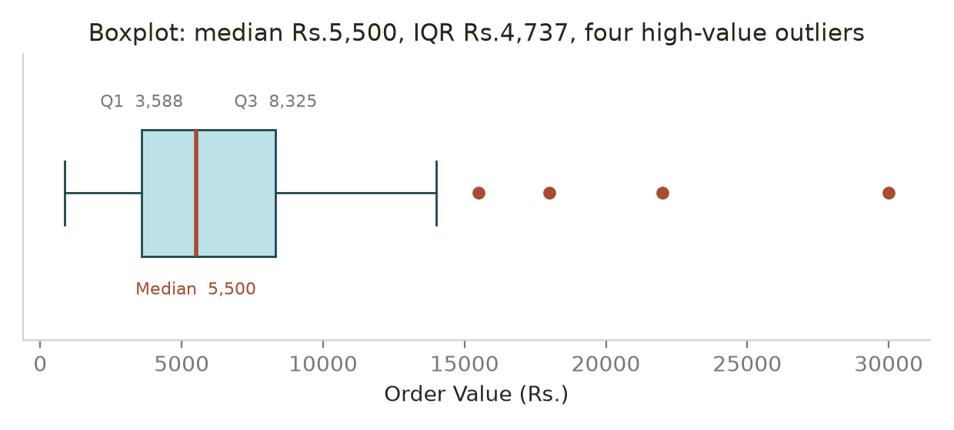
Analyze the histogram:
- What does the shape look like?
Unimodal with a long right tail — right-skewed.
- Where are most orders concentrated?
Below ₹5,000 (44% of customers); 82% are below ₹10,000.
- Is the distribution symmetric?
No.
- Does it appear right-skewed or left-skewed?
Right-skewed.
- Are there extreme values?
Yes — ₹15,500, ₹18,000, ₹22,000 and ₹30,000.
Analyze the boxplot:
- Identify the median.
Median = ₹5,500
- Identify Q1 and Q3.
Q1 = ₹3,587.50, Q3 = ₹8,325.00
- Identify the IQR.
IQR = ₹4,737.50 (the width of the box).
- Identify potential outliers.
Four points beyond the right whisker: ₹15,500, ₹18,000, ₹22,000, ₹30,000.
Business Question: Which visualization would you use to quickly identify potential outliers? Why?
The boxplot — it applies the 1.5 × IQR rule and plots each outlier as a separate point.

7. Skewness & Kurtosis Awareness
- Determine whether the Order_Value distribution appears approximately symmetric, right-skewed or left-skewed.
Right-skewed; skewness = +2.22.
- Explain what the skewness tells you about customer spending.
Most customers spend little, a few spend a lot, and those few pull the average up.
- Check the kurtosis using Python.
df['Order_Value'].kurtosis() = 6.39 (excess kurtosis).
- State whether the distribution shows relatively heavier or lighter tails compared with a normal distribution.
Heavier tails — excess kurtosis +6.39 vs 0 for a normal distribution.
- Do not focus on mathematical derivation.
Noted — used only as indicators, no derivation.
Business Interpretation: Why might an e-commerce company naturally have a right-skewed order-value distribution?
Order value has a floor at zero but no ceiling, and a few bulk or premium orders create a long right tail.

8. Probability
Using the dataset, calculate:
- Probability that a randomly selected customer is a Repeat Customer.
P = 16/50 = 0.32 (32%). Two-thirds of customers are first-time buyers — a retention gap.
- Probability that an order has a discount greater than 20%.
P = 14/50 = 0.28 (28%). Over a quarter of orders carry a deep discount, which is a margin cost.
- Probability that an order takes more than 5 days to deliver.
P = 5/50 = 0.10 (10%). One in ten deliveries is slow, and slow delivery lowers ratings.
For each probability, provide the numerical answer and a clear business interpretation.
Done above — all are empirical probabilities (favourable cases ÷ 50).

9. Conditional Probability
Calculate the probability that a customer is a Repeat Customer given that their Order_Value is greater than ₹5,000.
P(Repeat | Order_Value > ₹5,000) = 13/28 = 0.4643 (46.4%).
- Calculate the overall probability of being a Repeat Customer.
P(Repeat) = 16/50 = 0.32 (32%).
- Compare the two probabilities.
46.4% vs 32% — a gap of 14.4 percentage points.
- Which probability is higher?
The conditional probability, 46.4%.
- What does the difference suggest?
Spending and repeat status are positively associated, not independent.
- Does this prove that high spending causes repeat purchases?
No — association only. Reverse causality and confounders are equally possible.
- Give one possible factor other than Order_Value that could influence repeat purchasing.
Delivery experience: rating falls from 5.0 at 1 day to 3.0 at 6 days (r = −0.58).

10. Random Variables
- Identify two discrete random variables from the dataset.
Items_Purchased and Delivery_Days.
- Identify two continuous random variables from the dataset.
Order_Value and Marketing_Spend.
- Explain why you classified each variable that way.
Counts are discrete (whole numbers only); measured amounts of money are continuous.
- Suppose the company randomly selects one customer. Define X = Order_Value of the selected customer. Explain what possible values X can take.
X is continuous. Any positive value; here ₹850 to ₹30,000, each observed value with probability 1/50. E(X) = ₹6,939.
- Define Y = Items_Purchased. Explain how Y differs from X as a random variable.
Y is discrete — whole numbers 1 to 12, so P(Y = 5) = 0.10 is meaningful, whereas for X only intervals are. Y is bounded; X is not.

11. Sampling & Sampling Bias
Business Scenario: The company has 50,000 customers but can survey only 500 customers.
- How would you select the sample?
Build a frame of all 50,000 customers, split into strata, then select randomly within each stratum.
- Would you use probability or non-probability sampling?
Probability sampling.
- Which sampling technique would you recommend?
Stratified random sampling, stratified by Order_Value_Band and Repeat_Customer.
- Why?
Spending is skewed and Premium customers are only ~8% of the base; stratifying guarantees they are represented and lowers the standard error.
- What could go wrong if the sample is not representative?
Results would be biased, and the bias does not shrink with a larger sample — wrong averages, invalid confidence intervals, missed segments, wrong decisions.
Scenario 2: The company asks only customers who purchased during the last 7 days to complete a satisfaction survey.
- Is this necessarily representative of all customers?
No.
- Who might be missing?
Older, lapsed, churned, seasonal and occasional customers, and anyone whose order has not yet been delivered.
- What type of bias could occur?
Selection/coverage bias, survivorship bias, recency bias and non-response bias — satisfaction will be overstated.
- How would you improve the sampling approach?
Sample from all 50,000, stratify, include lapsed customers, widen the window, survey after delivery, use several channels, and weight for non-response.
Scenario 3: The company selects 500 customers simply because they are easiest to contact. Identify the sampling approach and discuss its limitation.
Convenience sampling. Selection probabilities are unknown, so results cannot be generalised and no margin of error can be computed; the bias does not shrink with sample size.

12. NumPy Sampling Simulation
- Randomly select 10 customers from the 50-row dataset.
rng.choice(values, 10, replace=False) → [4150, 7800, 2600, 7200, 1450, 2750, 4600, 4750, 8400, 4000]
- Calculate the sample mean of Order_Value.
Sample mean = ₹4,770.00 (₹2,169 below the true mean).
- Repeat the process 100 times.
means = [rng.choice(values, 10, replace=False).mean() for _ in range(100)]
- For each sample, select 10 customers randomly, calculate the sample mean and store the result.
100 means stored: average ₹6,770.55, SD ₹1,649.49, range ₹3,540–₹11,550.
- Create a histogram of the 100 sample means.
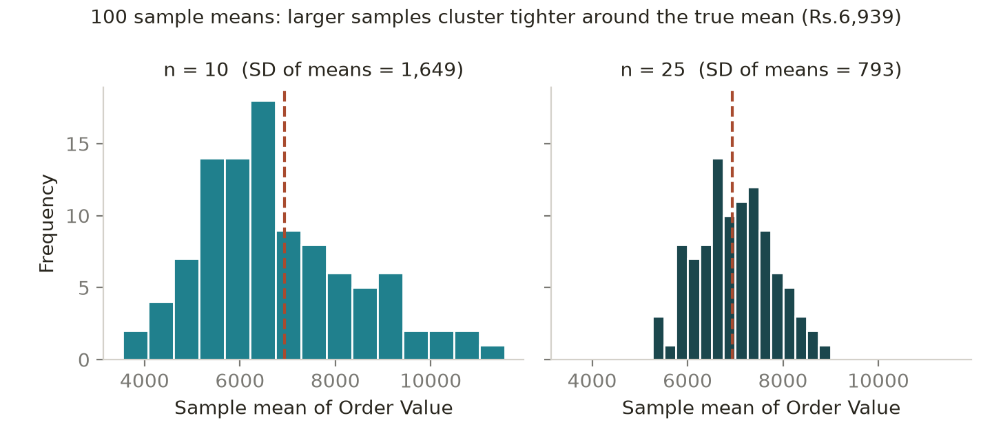
- Are all sample means identical?
No — 95 of the 100 are different, ranging ₹3,540 to ₹11,550.
- Why do they differ?
Sampling variability — each sample contains a different subset, and whether it includes an outlier changes the mean.
- What happens if you increase the sample size from 10 to 25?
SD of the means falls from ₹1,649 to ₹793 and the histogram narrows (SE = σ/√n).
- Which sample size would generally produce more stable sample means?
n = 25 — roughly half the standard error.

13. NumPy Implementation
Using NumPy, calculate the following for Order_Value:
values = df['Order_Value'].to_numpy()
- Mean
np.mean = 6,939.00
- Median
np.median = 5,500.00
- Variance
np.var(ddof=1) = 29,681,866.33 (np.var default = 29,088,229.00)
- Standard deviation
np.std(ddof=1) = 5,448.11 (np.std default = 5,393.35)
- Minimum
np.min = 850
- Maximum
np.max = 30,000
- 25th percentile
np.percentile(values, 25) = 3,587.50
- 50th percentile
np.percentile(values, 50) = 5,500.00
- 75th percentile
np.percentile(values, 75) = 8,325.00
- 90th percentile
np.percentile(values, 90) = 12,650.00
- Compare your NumPy results with your manual/statistical calculations.
All match. Only difference: NumPy defaults to ddof = 0, pandas to ddof = 1.
- Use NumPy to calculate the IQR from Q1 and Q3.
iqr = np.percentile(values,75) − np.percentile(values,25) = ₹4,737.50

14. Final Business Interpretation
You are now the Data Analyst for the e-commerce company. Prepare a short management summary based on your analysis.
- Customer spending — What does the center and spread tell us?
Finding: typical spend ₹5,500, spread very wide.
Evidence: mean ₹6,939, median ₹5,500, SD ₹5,448 (CV 78.5%), IQR ₹4,737.50.
Interpretation: a few large orders lift the mean; the median describes the real customer.
Implication: report the median and set offer thresholds just above ₹5,500.
- Customer spending distribution — What does the histogram/boxplot tell us?
Finding: unimodal, strongly right-skewed, heavy-tailed.
Evidence: skewness +2.22, kurtosis +6.39; 82% of customers below ₹10,000.
Interpretation: large orders are a normal feature, not freak events.
Implication: plan around the ₹3,588–₹8,325 core; use median and IQR in dashboards.
- Outliers — Are there unusual customers/orders? What should the business investigate?
Finding: four outlier customers, valuable not erroneous.
Evidence: C004 ₹30,000, C044 ₹22,000, C007 ₹18,000, C009 ₹15,500 — 8% of rows, 24.6% of revenue.
Interpretation: all bought 12 items, so the values are genuine; revenue is concentrated.
Implication: segment and protect them; do not delete; watch concentration risk.
- Customer behaviour — What does probability/conditional probability tell us?
Finding: loyalty and spending are linked, and loyalty is weak.
Evidence: P(Repeat) 32%; 46.4% above ₹5,000 vs 13.6% below; repeat customers spend ₹10,466 vs ₹5,279.
Interpretation: high spenders are likelier to return, but the cause is unproven.
Implication: target retention at customers already above ₹5,000.
- Sampling — What should the company consider when conducting a customer survey?
Finding: survey design decides whether results are usable.
Evidence: 500 of 50,000; Premium band only ~8%; last-7-days and convenience samples are biased.
Interpretation: a naive sample can miss the high-value group.
Implication: stratified random sampling, include lapsed customers, weight for non-response.
- Relationships — What relationships did you find?
Finding: two relationships matter, one does not.
Evidence: Marketing–Order r = +0.857; Delivery–Rating r = −0.582; Discount–Order r = −0.066.
Interpretation: marketing tracks value, slow delivery lowers ratings, discount depth does nothing.
Implication: fix slow delivery; review the discount policy.
- Correlation vs causation — Which relationship should management be careful not to interpret causally?
Finding: Marketing_Spend vs Order_Value must not be read causally.
Evidence: r drops from +0.857 to +0.595 without the four outliers; n = 50, observational.
Interpretation: marketing is aimed at customers already known to be valuable.
Implication: run a controlled test before increasing budget.
- Recommendation — Give two practical business recommendations based on your analysis.
1. Retention programme for one-time buyers above the ₹5,500 median — repeat customers spend ₹10,466 vs ₹5,279, and only 32% of the base is repeat. Measure the 90-day second-purchase rate.
2. Fix the slow-delivery tail (10% of orders take over 5 days; r = −0.58 with rating) with a 95%-within-4-days target, funded by capping discounts above 20%, which show no lift (r = −0.07).
Use the structure: Finding → Evidence → Interpretation → Business Implication.
Noted — section 14 follows that structure.

15. Correlation vs Causation
Investigate these relationships:
- Marketing_Spend vs Order_Value
- Delivery_Days vs Customer_Rating
- Discount_Percent vs Order_Value
- Create a scatter plot.
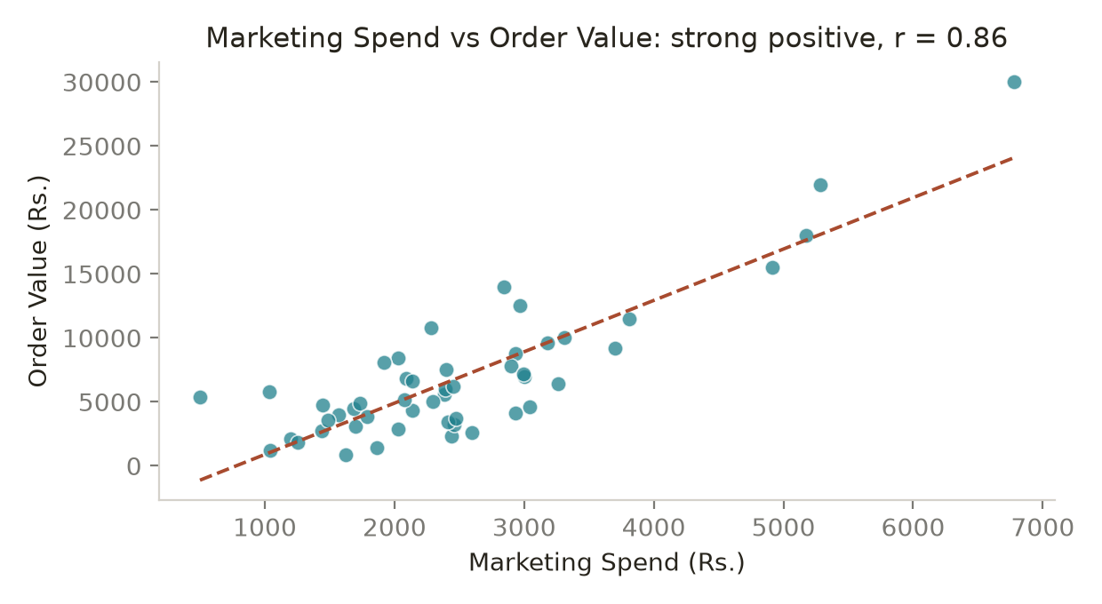
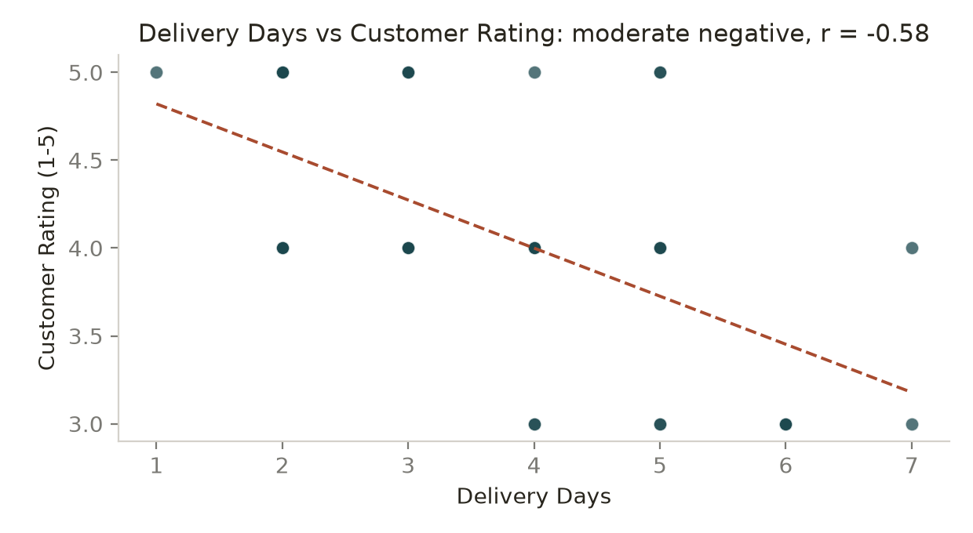
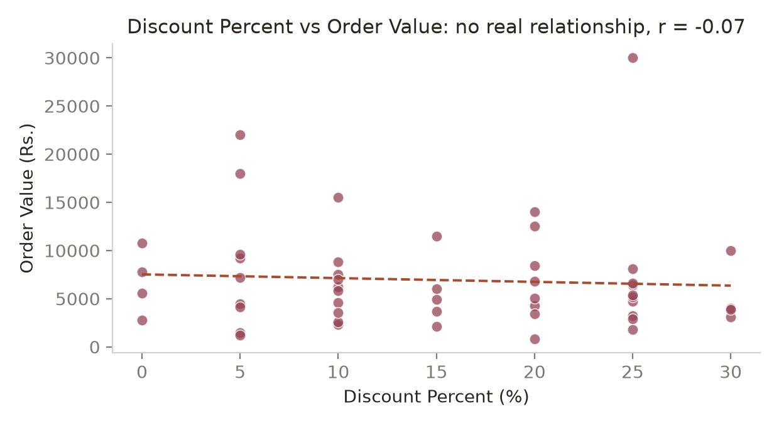
- Calculate correlation.
Marketing_Spend vs Order_Value: r = +0.857
Delivery_Days vs Customer_Rating: r = −0.582
Discount_Percent vs Order_Value: r = −0.066
- Identify the direction.
Positive · Negative · Effectively none.
- Comment on the strength.
Strong (r² = 0.735) · Moderate (r² = 0.339) · Negligible (r² = 0.004, p = 0.65).
- Interpret the relationship.
Marketing and order value rise together, but because marketing targets valuable customers. Longer delivery lowers ratings (5.0 at 1 day → 3.0 at 6 days). Discount depth has no effect on basket size.
- Check whether unusual observations could influence the relationship.
Yes — excluding the four outliers, Marketing–Order falls from +0.857 to +0.595. The other two barely change. Outliers kept, results reported both ways.
Critical Question: If Marketing Spend and Order Value have a strong positive correlation, can you say “Increasing marketing spend causes order value to increase”? Explain why or why not.
No. Reverse causality (budget follows value), confounders, no time ordering, only n = 50, and r drops to +0.595 without four rows. Say "strongly associated"; prove causation with a randomised test.

16. Covariance
Calculate the covariance between Marketing_Spend and Order_Value.
Cov = +5,433,311.78 (ddof = 1)
- Is covariance positive or negative?
Positive.
- What does the sign tell you?
The two variables move in the same direction.
- What does the magnitude tell you?
Nothing reliable — the size depends on the units and has no upper limit.
- Why is covariance difficult to interpret by itself?
It is unbounded, unit-dependent (₹ × ₹) and changes with scale, so there is no benchmark and no comparison across variable pairs.
- How does correlation make interpretation easier?
Correlation divides by the two SDs: 5,433,311.78 ÷ (1,163.33 × 5,448.11) = 0.857 — unit-free, bounded −1 to +1, comparable and testable.
Business Question: If covariance between marketing spend and sales is positive, what does that suggest? What can you say, and what can you NOT say?
CAN say: marketing spend and sales move together; they are not independent.
CANNOT say: that spend causes sales, how strong the link is from the covariance alone, or how much extra sales an extra rupee buys. Test with a controlled experiment.

Final Submission Requirements
- Python Notebook (.ipynb) containing calculations, NumPy implementation, sampling simulation, visualizations, correlation and covariance.
Prepared: Statistics_Data_Analytics_Analysis.ipynb
- Business Analysis Report — maximum 3 pages.
Prepared: the section 14 management summary (under 3 pages).
- Minimum visualizations: 1 histogram, 1 boxplot, 2 scatter plots and 1 sampling simulation visualization.
Included: 1 histogram, 1 boxplot, 3 scatter plots, 1 sampling histogram.
- All major statistical results must include interpretation.
Complied — every result is interpreted.
- Do not submit calculations without explanations.
Complied — no figure without explanation.
- Do not make causal claims from correlation alone.
Complied — no causal claim made from correlation.
- Do not remove outliers without investigating them.
Complied — the four outliers were investigated and kept.

Evaluation Focus
- Correct application of statistical concepts.
- Correct calculations.
- Appropriate choice of statistical measure.
- Interpretation of results.
- Identification of sampling issues and bias.
- Distinguishing correlation from causation.
- Effective use of NumPy for statistical analysis.
- Ability to communicate findings in business language.
Calculate → Interpret → Question → Decide → Communicate

